**Smart Hand Wash System to Overcome S.S.I Problems in Hospitals**

Priyanka Patil1, Savita Jadhav1, Alka Gupta2, Shashank Shende2, Ashish Naidu2

1 Assistant Prof. (Dept. of Electronics and Telecommunication Engg), SPPU 2 Student (Dept. of Electronics and Telecommunication Engg), SPPU

# Abstract—

Staff adherence to hand hygiene standards is critical in healthcare environments such as hospitals and clinics.

It is one of the most effective strategies for minimising infections associated with healthcare.

The effectiveness of each episode of hand washing is also important, and it can be done by adhering to some established recommendations, such as those issued by the World Health Organization (WHO). The recommended approach for washing hands is rubbing the hands in a variety of ways to ensure that no portion of the hands is overlooked. Surgical site infections endanger the lives of millions of individuals every year because hospitals fail to follow adequate hand washing procedures before staff members undertake operations (SSI). As a result of these infections, antibiotic resistance would spread. We design an automated smart hand washing system to avoid surgical site infections and reduce the amount of illnesses that endanger human life by observing the numerous hand washing procedures advised by the World Health Organization. By maintaining the necessary information, the Hospital Infection Control Committee will be able to easily monitor each individual.

***Keywords*— Hand hygiene, Passive Infrared Sensor, Camera Module, RFID Reader, Buzzer, Open CV, Databases, CMU.**

# 1. Introduction —

The World Health Organization (WHO) has developed guidelines for a six-step "hand massage," since hand hygiene is becoming an important preventative practice strategy for alcohol-based disinfection.

According to a 1996 study of medical personnel, the six-step hand washing procedure is not usually strictly performed.

The efficacy of disinfection is brought into question because 57% of the workers had non-infected skin patches on their thumbs and 35% had them on the tips of their fingers. In another study, a higher percentage—60% of those tested— were unable to employ an adequate hand washing strategy.

Because it has been demonstrated that maintaining good hand hygiene is critical for preventing nosocomial infections, it is critical to establish concrete measures to promote this action. Hand hygiene is critical in healthcare environments such as hospitals and clinics.

Guidelines, proper hand washing procedure contains different ways of hand wash procedures to ensure that no area of the hand is missing.

Surgical Site Infections threaten millions of lives each year because hospital workers present with doctors do not follow adequate hand washing recommendations before to surgery (S.S.I). During surgery, Surgical Site Infections (S. S. I.) arise.

To avoid Surgical Site Infections (S. S. I), it is vital to wash hands adequately for at least 3 minutes using the World Health Organization's standard guidelines. To guarantee adequate hand hygiene, the World Health

Organization has given six alternative hand washing routines.

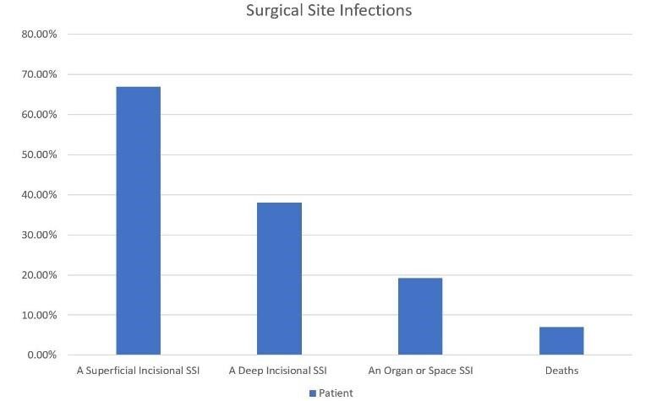

*Fig1. SSI Graph*

|  |
| --- |
| Smart Hand Wash System to Overcome Surgical Site Infections Problem in Hospitals 2 |

## 1.1 The Hand Wash System

The smart hand wash system will properly monitor hand positions in accordance with World Health Organization recommendations. With the help of deep learning and image processing, the camera module will scan the positions of the hands and match the exact positions with the fetched images in the code. If any of the users' or hospital staff's hand positions are not correctly recognized or go wrong in any way, the buzzer will sound, alerting the user, and the image of the incorrect hand position will be placed in the database for proper monitoring and action.

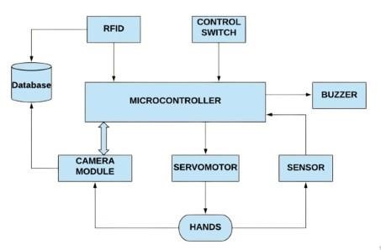

*Fig2. Hand Wash System Architecture*

Since we are deploying a Continuous Monitoring Unit (C. M. U.) that will continuously monitor the user's hand locations for three minutes, someone will need to wash their hands for three minutes.

The World Health Organization has established six distinct hand washing strategies, each of which should take no more than 30 seconds. A camera will now capture the hand process every 5 seconds for the next 30 seconds. If the participant fails to apply the proper hand technique, the camera will observe and give them an extra 10 seconds to alter their hand position in accordance with the requirements. If the person's hand placements remain unchanged, the buzzer will sound.

After the first 30 seconds have gone, the machine will continue with the next hand process for another 30 seconds. The software element of the system is built with the strong Open CV library. The library includes around 2500 algorithms, including a variety of computer vision and machine learning methods. These algorithms can be used to track camera movements, identify moving objects, classify human actions, and detect and recognize a variety of

faces, and recognize items. It is compatible with Windows, Linux, Android, and Mac OS, and it includes C++, Python, Java, and MATLAB interfaces.

The doctor's arrival and leave timings, as well as the overall amount of time spent hand cleaning, will be recorded in the database. This project is being tested in real time.

1. *Passive Infra-Red (PIR)Sensor*

The PIR sensor is installed on the product's vertical. A Passive Infrared Sensor (PIR Sensor) is utilized to construct a Touch Free Water Tap Controller. The PIR sensor detects infrared photons (IR). When a human hand moves beneath the PIR sensor, it detects the differential IR radiations from the movement and declares the presence of a human hand.

1. *Camera Module*

The camera module will capture the user's hand positions and apply a sophisticated canny edge detection algorithm to detect the edge of the hand locations (in edge detection window).

It will count the contours of the standard image before comparing them to the user's hand image. If both photos match, the hand position is shifted to the next hand position, and so on until all six hand positions are matched.

If any of the hand positions are not perfectly matched as per the W.H.O guidelines, the system will give the user a "10 seconds" interval to fix the position, and if even that is not done properly, a buzzer will sound, alerting hospital staff members, and the records of the user's irresponsible act will be stored in the database.

1. *RFID Reader*

Using the approach described above, we will obtain an ordinary hand wash solution for 3 minutes at intervals of 3 minutes.

In an emergency, the RFID reader will read the RFID tag, and the RFID controller will send signals to the microcontroller to twist the servomotor anticlockwise.

In the anti-clockwise orientation, we will acquire a powerful solution that will enable us clean our hands in less than a minute. Chlorohexadine solution is used for this purpose.

The several hand hygiene practices will be displayed on the

LCD.

|  |
| --- |
| Smart Hand Wash System to Overcome Surgical Site Infections Problem in Hospitals 3        *D. Open CV* ***1.2 Benefits of the System*** |

Open CV (Open Source Computer Vision Library) is a free and open source computer vision and machine learning software library.

The library contains over 2500 optimized algorithms, including a complete variety of both classic and cutting-edge computer vision and machine learning techniques.

These algorithms can be used to detect and recognize faces, identify objects, classify human actions in videos, track camera movements, track moving objects, extract 3D models of objects, produce 3D point clouds from stereo cameras, stitch images together to produce a high resolution image of an entire scene, find similar images from an image database, remove red eyes from images taken with flash, follow eye movements, recognize scenery, and establish markers to overlay.

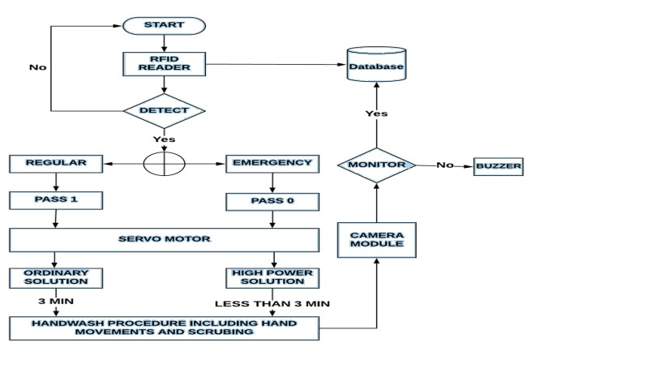

*Fig3. Flow Chart of the System*

1. Hygiene -: Thorough hand washing is effective in reducing the spread of germs. Keeping in mind the numerous hand washing strategies supplied by the World Health Organization, this system would maintain hygiene standards, preventing fatalities due to unsanitary hand washing methods.

1. Cost -: Because of the low maintenance and low-cost sanitizers, the system is significantly less expensive than other smart hand wash systems on the market with less functions.

1. Waste -: Smart hand washing systems are more environmental friendly than traditional hand washing systems.

## 1.3 Objectives of the System

In order to prevent surgical site infections and lower the risk of illnesses that pose a threat to human life, we develop an automated smart hand washing system that keeps track of the various hand washing methods recommended by the World Health Organization.

The Hospital Infection Control Committee will be able to monitor the individual more easily if the right database is maintained.

To create a smart hand washing system that would monitor hand hygiene.

This system will track how much time people spend before and after surgeries.

In an emergency, this technique will help to boost the efficiency of hand hygiene in the shortest amount of time.

We can use the Database to record the time spent by each individual doctor before and after surgery by following the World Health Organization's criteria.

# 2. Algorithm of the system

1. Start the system by placing your hands in front of sensors.
2. Hand detection by RFID reader.
3. If Hand detected, user input for regular or Emergency 4. If regular, Pass 1 executed through servo motor dispensing of ordinary solution.
4. If Emergency, Pass 2 executed through servo motor dispensing of High power solution.
5. Hand wash procedure including hand movements and scrubbing through camera module.
6. Monitoring and verifying the hand movements.
7. If any error occurs buzzer is triggered.

|  |  |  |  |  |  |
| --- | --- | --- | --- | --- | --- |
| **Sr.no.** | **Title of paper** | **Author’s name** | **Journal /Conference title** | **Year** | **Findings** |
| **1** | **Distributed IR based technology to monitor hand hygiene of healthcare staff** | **A.I. Levchenko,** | **2013 IEEE Toronto International Conference** | **2013** | **\*Detection of bacteria rate.**  **\*regulation of infrared emission intensity.**  **\*increasing the accuracy of issuing a prompting signal.** |
| **2** | **An Autonomous Hand Hygiene Tracking Sensor System for Prevention of Hospital Associated Infections** | **David Cheng zarate** | **IEEE SENSORS JOURNAL CONFERENCE**  **2020** | **2020** | **\*** **Relationship between RSSI and distance**  **\*The smart ABHR dis-pensors can recognize and record subjects.**  **\*** **The hand hygiene data, such as time, location, and frequencies, are successfully recorded.** |
| **3** | **Automated Hand Hygiene Monitoring System Using Imagery and Bluetooth Low Energy Sensors** | **Ahmed Soliman** | **IEEE International Conference of control system** | **2018** | *S**tandardized measurement tools to evaluate system performance are lacking**  **\* narrative approach to synthesize the extracted data** |

|  |  |  |  |  |  |  |  |  |  |  |  |  |  |  |  |  |  |  |  |  |  |  |  |  |  |  |  |  |  |  |  |  |  |  |  |  |
| --- | --- | --- | --- | --- | --- | --- | --- | --- | --- | --- | --- | --- | --- | --- | --- | --- | --- | --- | --- | --- | --- | --- | --- | --- | --- | --- | --- | --- | --- | --- | --- | --- | --- | --- | --- | --- |
| *Fig4.trends of hand hygiene compliance*  The most efficient and most cost effective method for preventing health care associated infections is hand hygiene. Although hand hygiene is the most effective and simple method, compliance rates are very low among health care workers. It was aimed to evaluate the rates of compliance of healthcare workers in a state hospital   |  |  |  |  |  |  | | --- | --- | --- | --- | --- | --- | | Sr.no. | Total Opportunity | Opportunity | Hand washing | Hand rubbing | Compliance nce% | | 1. Before patients contact | 169 | 50 | 0 | 27 | 54.00 | | 2.After body fluid exposure | 101 | 20 | 3 | 6 | 45.00 | | 3. Before Aseptic task | 88 | 8 | 0 | 8 | 100.00 | | 4.After patient contact | 209 | 55 | 2 | 24 | 47.27 | | 5. After patient surroundings | 223 | 66 | 0 | 32 | 48.8 |   **Algorithm:**  1.User shows ID card to Hygine Detector  2.Using open CV the device detects the card and prints id number  3.if correct then the device checks for simulated germs .  4. checks if the germ level is below a threshold.  5.prints acess granted and person can enter hospital |

This observational, quasi-experimental intervention study shows the benefits of a prospective multimodal strategy enhancing hand

*Fig5. Per year compliance percent*

hygiene compliance in gynaecology and obstetrics in a lower-middle-income country in Southeast Asia. Hand hygiene improved significantly from a low compliance in 2010 to reach 65% in 2015 and 75.1% in 2018. The high number of observed hand hygiene opportunities together with the prospective, continuous measurement of HAI over 9 years in a highvolume referral maternity hospital, makes this study unique and the largest in the field of hand hygiene in gynaecology and obstetrics to the best of our knowledge.

|  |  |  |  |
| --- | --- | --- | --- |
| Sr.no | Compliance%  2010 | Compliance%  2011 | Compliance%  2012 |
| 1.Hand washing | 7.8 | 9.2 | 9.3 |
| 2.Hand rubbing | 13.7 | 32.2 | 45.3 |

Hand hygiene monitoring and compliance system :

**Algorithm:**

1.scan ID card

2.Ensure a picture of the whole Id card has been clicked

3.Conver image to grey scale.

4.Use bilateral filter to remove noise.

5.Template matching to find registration number.

|  |
| --- |
| Smart Hand Wash System to Overcome Surgical Site Infections Problem in Hospitals 4 |

# 3. Comparative Analysis

The parallels and contrasts between this model and prior models are the topic of this comparative analysis.

According to the research on prior models, the hand wash system had few downsides, and their efficiency also decreased as the technology grew older.

The table below explains the holes discovered and the

improved version of this system:-

|  |  |  |  |
| --- | --- | --- | --- |
| Sr.  No. | Findings 1 | Findings 2 | Improvised Model |
| 1. | A prototype system of interconnected handhygiene stations using a combined wireless sensor network  (WSN). | Internet-ofThings (IoT) technologies  are being used to track the rate of hand hygiene compliance. | For accurate findings, Deep Learning  techniques such as  Convolutional Neural Networks (CNN) are used. |
| 2. | To detect the human presence, a system for hand hygiene compliance is designed that uses radio frequency identification. | To detect the user's  presence, an exclusive  RFID Reader is employed. | To recognize the human hand while distinguishing various users, a combination of the latest camera module and RFID Reader is employed. |

*Table1. Comparative Study*

# 4. Existing Procedures and their Disadvantages

The automatic smart hand wash system was created in the 1950s, but it was not commercialized until the late 1980s, when it first appeared to the general public in airport restrooms. Since then, automatic hand washing devices have emerged as a major theme. Several advancements and improved versions have made these automated hand washing systems more efficient, but they are still not ideal for this system. As a result, the following deficiencies have

been discovered and addressed in this project: -

1. Using percentage criterion with real-time feedback is ineffective in an emergency circumstance where a person must wash his or her hands in less than 3 minutes.

1. Finish monitoring is insufficient because if a user fails to complete the current hand stance, the system moves on to the next hand pose, resulting in inefficient system output.

1. The hand rest mechanism fails to detect suitable hand postures, and the three-minute guidelines are not observed.

# Results

The smart hand wash system will properly monitor hand positions in accordance with World Health Organization recommendations.

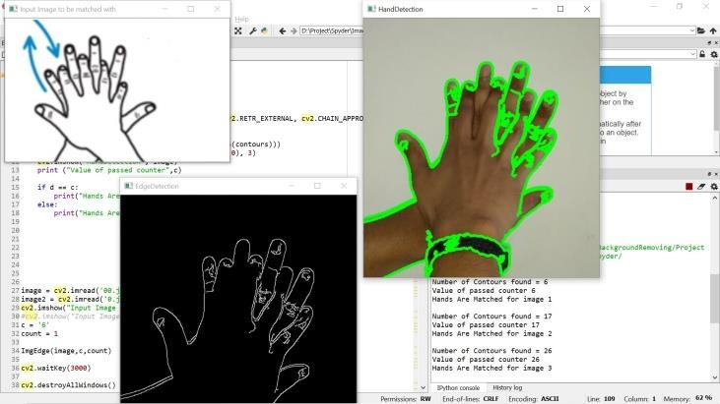

*Fig6. Hand Position 1*

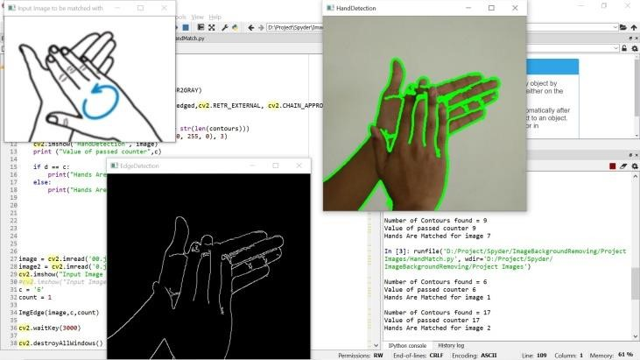

*Fig7. Hand Position 2*

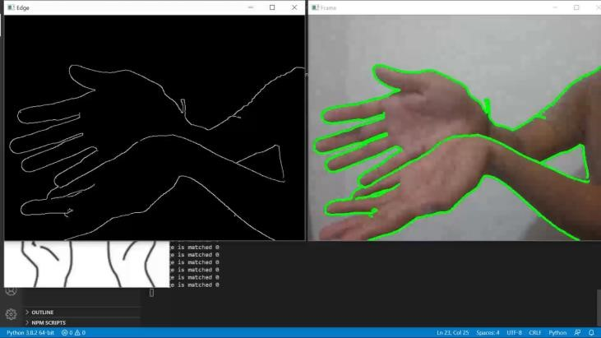

*Fig8. Hand Position 3*

|  |
| --- |
| Smart Hand Wash System to Overcome Surgical Site Infections Problem in Hospitals 5 |

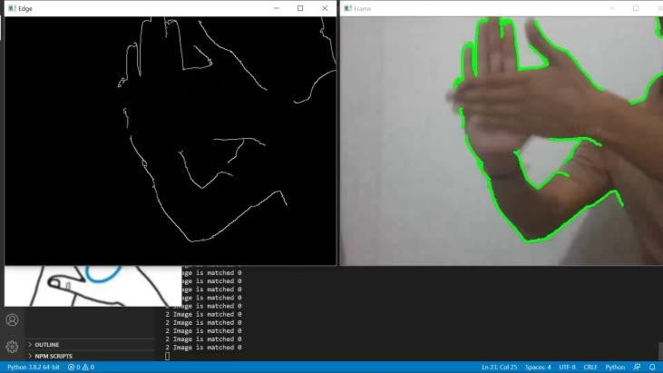

*Fig9. Hand Position 4*

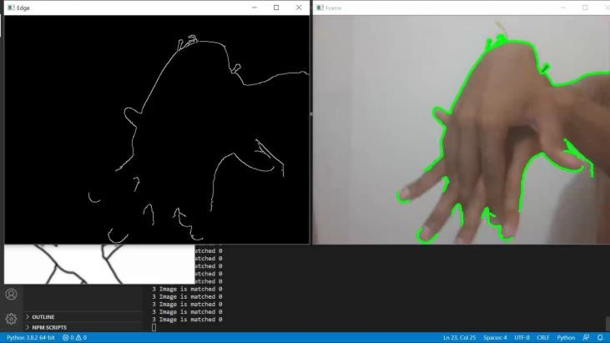

*Fig10. Hand Position 5*

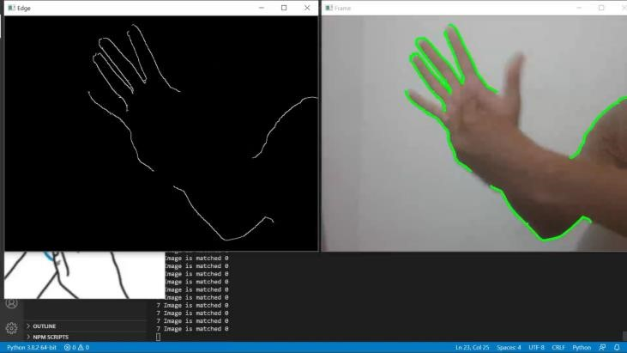

*Fig11. Hand Position 6*

As a result of the camera module detecting and matching all six hand positions, the algorithm's subsequent stages are carried out.

# 6. Conclusion

We can use a Continuous Monitoring Unit (C. M. U.) to continuously monitor the hand positions for three minutes, which will help to reduce the frequency of surgical site infections.

We can eliminate the manual attendance system by keeping the database.

Because of the PIR sensor system, a touch-free water control tap will be available.

This device will provide full hand hygiene while minimizing human effort within the time frame specified.

Maintaining perfect hand hygiene is particularly beneficial in government hospitals.

# 7. References

1. WP. Hongsoongnern, A. Britton, S. Varsha, “Reduced Germ

from Changing Out Mamal Soap and Sanitizer Dispensers to

Touchless Closed System Dispensers,” American Journal of Infection Control, pp. 78, 2016..

1. N. Kenters, A. Eikelenboom-Boskamp, J. Hines, “product Dose

Considerations for Real-world hand Sanitiser Efficiency.” American

Journal of Infection Control, pp. 503-506, vol. 48(3), 2020

[3] D. Rakshit, B. Baral, S. Datta, PB. Deb, P. Mukherjee, “Water Level

Indicator,” International Journal of Scientific & Engineering Research.

Pp. 7-10, Vol. 7(4), 2016.

1. A H.N.Le, C.Zln,Y. Zheng, K. Luu, M. Savvides, “Robust

detection in vehicles,” In Intl. Conf. on Pattern Recognition (ICPR),Pp. 573-578, 2016

1. MA.CWilkinson, K.Ormandy, C.R BradlA.P.Fraisea].Hinesb

“Dose considerations for alcobol-based hand mbs,” Journal of Hospital Infection, pp. 175-182, vol. 95(2), 2017.